

**The application of design in developing community tourism to experience Thai Nguyen tea culture**

**By**

Bui Van Duong

Student ID : GCH18238

**Supervised by**

Bui Thi Thanh Huong

**Submitted to**

*Department of Graphic Design*

**University of Greenwich Vietnam**

**ABSTRACT**

The study was carried out to analyze the tourism needs to experience tea culture of Thai Nguyen city people, and at the same time to apply the design to develop the experiential tourism industry. The data in the topic is collected by survey of 100 people in Thai Nguyen city to find out their need for experiential tourism. The study used two main methods: descriptive statistics and cross-tabulation analysis. Research results show that experiential tourism is a relatively new type of tourism and is a trend among young people today. Besides, the research also shows the activities that customers want to experience in a tour. Based on the analysis results, the study proposes a number of suitable recommendations and at the same time applies the design to create attractiveness for tour operators to meet the tourism experience needs of the people of Thai Nguyen city. better in the future.

**ACKNOWLEDGEMENTS**

First of all, I would like to thank Ms Huong for helping me in many aspects of conducting research, interactive ideas and writing this thesis. Her guidance, support, and assurance throughout the process helped me complete this complex project. Moreover, without her valuable suggestions in terms of art education, this project would be less effective and practical.

# 

****TABLE OF CONTENTS****

**I. INTRODUCTION 4**

**II. CHAPTER 1: UNDERSTANDING CULTURAL EXPERIENCE TOURISM** 5

2.1. Basic theory of experiential tourism 5

2.2 What is the difference between experiential tourism and other types of tourism? 5

2.3 Why is experiential tourism becoming a trend in recent years? 6

2.4 The benefits of experiential tourism 6

2.4.1 Join the World 6

2.4.2 Improve health  6

2.4.3 Change yourself 6

**III. CHAPTER 2: THE CULTURE AND TOURISM VALUE OF THE THAI NGUYEN** 7

3.1 Thai Nguyen is the first name of tea 7

3.2 What Is the attraction of Thai Nguyen tea culture experience tourism? 7

3.3 Culture of enjoying tea 9

**IV. CHAPTER 3: DESIGN FOR EXPERIENTIAL TRAVEL** 9

4.1 what is the theoretical basis for travel experience design? 9

4.2 How should tourist experiences be designed and researched? 10

4.3 How to capture the senses of tourists: Challenges and possible solutions ? 11

**V. CHAPTER 4: THE RISE OF NATIONAL CULTURAL IDENTITY IN MODERN DESIGN** 11

5.1 The way to bring national culture into modern design 12

5.2 National cultural identity: endless inspiration but also a challenge 14

**VI. METHODOLOGY** 14

6.1 Data collection methods 14

6.2 Data Analysis Methods 14

6.3 RESULTS AND DISCUSSION 14

6.3.1 Actual situation of tourists participating in tourism when coming to Thai Nguyen city 14

6.3.2 Experiential tourism needs of tourists when coming to Thai Nguyen 16

**VII. CONCLUSION** 19

**VIII. REFERENCES** 19

# **INTRODUCTION**

In the past, people used to travel with the purpose of discovering a new place, a place with many beautiful sights and services so that when we arrive, we can both relax and enjoy the beauty of nature and discover the cuisine and culture here. But now, people are tending to change a lot about travel. Want to travel to experience rather than relax, want to be immersed in the daily life of local people, want to be able to participate in activities and work in that place, want to be discovered the customs to the unique dishes. And perhaps, Thai Nguyen tea area is a great place to add to your Vietnam travel itinerary if you are a tea lover or want to learn about tea culture as well as the people who make tea here. Here, a land where perhaps when referring to the first tea, Thai Nguyen is mentioned

Since ancient times, tea has entered the Vietnamese soul naturally, the Vietnamese culture of enjoying tea is not only enjoying a popular daily drink in life but it has become a custom, a elegant hobby, a cultural feature of the Vietnamese nation. Taking advantage of this, Thai Nguyen tourism is developing many products associated with eco-tourism and community-based tourism in order to preserve and promote national cultural values as well as tea products to a large number of tourists. But it seems that the approach and communication with tourists has not really made them feel interesting if it is through documentaries, newspapers, and travel books before. Therefore, putting design into marketing activities, promoting experiential tourism is a completely new direction, easily bringing tourists to feel the typical cultural features through colorful images and emotions most touching.

The research will cover the following concerns:

- Cultural potential of Thai Nguyen in community tourism development.

- How does the application of design affect the development of the community tourism industry?

-How has the application of design to experiential tourism aroused the culture?

1. **CHAPTER 1: UNDERSTANDING CULTURAL EXPERIENCE TOURISM**

**2.1. Basic theory of experiential tourism**

Experiential tourism is a form of tourism that gives visitors the opportunity to experience real life in new environments. Participating in experiential tourism is an activity that immerses tourists in real life at tourist destinations through seeking information and participating in specific activities as members who directly affect the environment. local schools and communities. These activities will help visitors gain more understanding of the region's culture, along with many interesting experiences about living in a new environment different from everyday life. In addition, visitors will also accumulate more knowledge and practical experience about nature, culture and society by participating in specific activities with the local community.

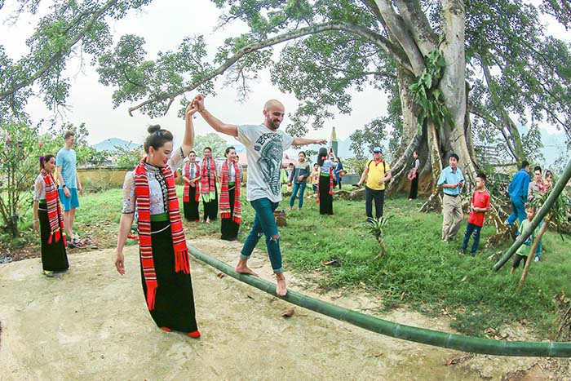

*Figure 1: Tourists experience folk games*

Currently, experience tourism is becoming a tourism trend for everyone, experience tourism is a fairly broad concept, it includes a series of other types of tourism such as cultural tourism, biological tourism, etc. ecotourism, educational tourism, discovery tourism, heritage tourism and nature discovery tourism. Experiential tourism minimizes the impact on the environment, shows respect for different cultures, requires visitors to be proactive and flexible to experience and learn, not merely stand and see to know.

Thus, in a general way, experiential tourism is any type of tourism that we are known, however, that the visitor experience factor is a top priority. Visitors have to be more active, interact with nature and the surrounding life more, do it themselves, and draw experiences for themselves. It can be special activities, new, interesting, related to culture, lifestyle, exploring nature... in a new land. Visitors will use all their senses to feel and create their own stories. Of course, it will make visitors impressed and remember more deeply about the trip than any sharing on advice pages or from others.

**2.2 What is the difference between experiential tourism and other types of tourism?**

As stated, experience tourism can be cultural tourism, heritage tourism, ecotourism or adventure tourism… In other words, experience tourism can be any type of tourism that There is an element of “experience”. The experience is expressed through visitors directly participating in activities, feeling with their senses, then drawing experiences or creating unique memories for themselves. The only difference and also the most important is that experiential tourism does not follow the trail, is not based on any standards.

choosing ordinary spots or boring activities, far from sightseeing tourism with the main purpose of enjoying, seeing the scenery, taking souvenir photos is the main thing. It requires visitors to be more active, more proactive and have to do it all by themselves. The tour guide is no longer a presenter or an ordinary cheerleader, but now, the guide plays the role of an initiator, leading visitors into activities, observing and assisting when needed. set.

Even tourism service providers see the potential for this type of development. They think that many tourists are impressed by the type of experience tourism for the seemingly simple reason but the trend of tourism in the future (traveling with the feeling of not being constrained, being imposed according to the self-contained program, merely sleeping and resting of the traditional tours). For those who are passionate about travel, especially foreign tourists, they really want to discover and experience the places they go to, to feel the true travel space while still ensuring safety. completely compared to the form of tourism "phuot". In addition, with reasonable prices, packaging time are the factors that make tourists

Experience tours are becoming the favorite choice of domestic and international tourists.

**2.3 Why is experiential tourism becoming a trend in recent years?**

Previously, tourists came for the sole purpose of sightseeing and relaxation, but now there is a demand for high-quality resorts, because they want to learn more about the growing indigenous cultural values.

In the era of creative tourism, tourists play a leading role in the "game" rather than just spectators who only see the beauty of nature, tourists are increasingly attracted by new values. based on traditional cultural values (distinctiveness, originality, originality), natural values (primitiveness, originality), creative values, high technology (modernity, convenient).

**2.4 The benefits of experiential tourism**

**2.4.1 Join the World**

**Traditional tourism provides less intriguing and novel experiences than experiential tourism. This form of travel might help you rediscover your passion for living, studying, and working. You have the option to travel the world by leaving familiar locations. However, this journey will need more of you in terms of health, time, and knowledge. Strangers' relationships can be strengthened through experiential activities. In the regions, you may learn more about the country's distinct customs. This form of travel is ideal for persons who enjoy learning about the world around them.**

### ****2.4.2 Improve health****

The health advantages of each of your excursions are enormous: Reduce your stress levels, and you'll lower your chance of heart disease. In addition, exercise improves joint flexibility and overall wellness. Exercising on a daily basis will make you feel more energized, cheerful, and healthy. We frequently become engrossed in the family, professional, and social interactions that surround us, resulting in stress. This form of travel will allow you to momentarily put work and exhaustion aside in your daily life.

****2.4.3 Change yourself****

**Experiential travel allows you to grow as a person by participating in new and exciting activities. Enjoy delectable cuisine while learning about other locations' native cultures. People will see a different side of you when you tell them about these experiences: smart and engaging. Instead of sitting at home and learning through books, you will break many things if you go for a day of studying and studying smartly. That is why there is a proverb that goes, "The world is a book, and those who do not travel can only read one page of that book."**

# **CHAPTER 2: THE CULTURE AND TOURISM VALUE OF THE THAI NGUYEN**

**3.1 Thai Nguyen is the first name of tea**

Thai Nguyen is the central province of the northeastern midland and mountainous region, with a natural area of 3541km2, a population of over 1.2 million people and 09 ethnic groups; There are 09 administrative units with a fairly comprehensively developed infrastructure system that is convenient for socio-economic development. During the resistance war against the French colonialists (1947-1954), Thai Nguyen was a safe zone and a capital city. The resistance capital of the whole country, built by Uncle Ho, the Party Central Committee's headquarters, led the resistance to make the historic Dien Bien Phu victory "splendid in five continents, shaking the world". As a land rich in revolutionary traditions, rich in history and culture; is the cradle of mankind with the evidence at Than  Sa Archaeological Site (Vo Nhai); is the land of famous people in history: Ly Nam De, Duong Tu Minh, Luu Nhan Chu... Thai Nguyen is also proud to be the home of the famous "First Name Tra" land.

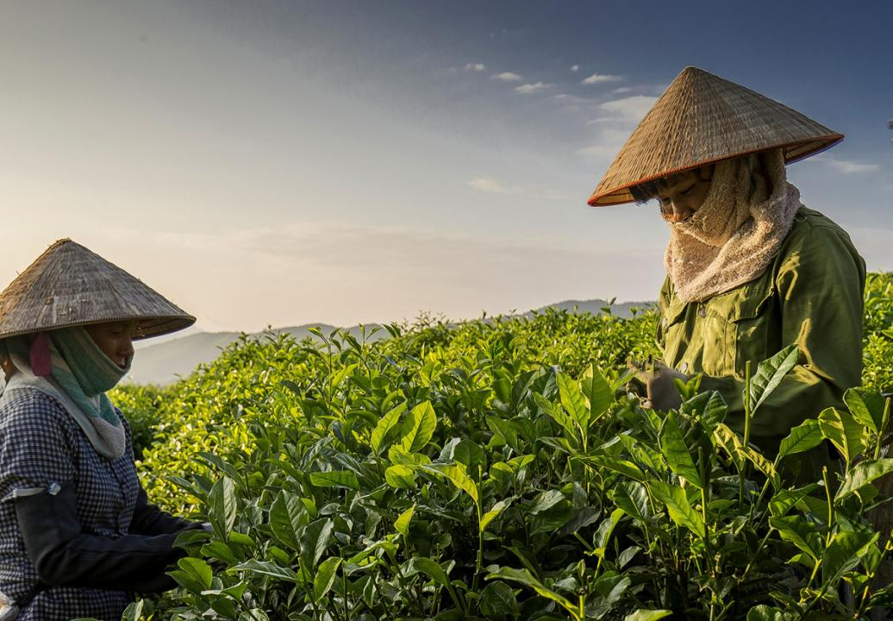

*Figure 2: Thai Nguyen is famous for tea*

Referring to Vietnamese tea, people immediately think of Thai Nguyen tea with delicious taste and distinct characteristics. In the province, tea is grown in all districts, cities and towns. Tea trees are closely associated with the lives of Thai Nguyen people. In addition to bringing great economic value, tea trees also carry traditional cultural features and potential for tourism development for local people. Many regions specialty teas such as Tan Cuong, Trai Cai, Tuc Tranh, La Bang with products meeting national and international quality standards continue to affirm the "First Name Tra" brand.

For Thai Nguyen people, tea products are present in every important event of each family, village, and workplace; from filial piety to village festivals, communal festivals, and festivals; Tea is used as a means of communication instead of thanking and gratitude to friends, relatives, partners... Drinking tea has become a habit, an indispensable need in daily life.

**3.2 What Is the attraction of Thai Nguyen tea culture experience tourism?**

In particular, visitors will learn about the history of tea through museum galleries or be told by longtime tea artisans here about the history of transformation and development of tea culture from ancient times to the present. Visiting two main sites is the factor that makes the tea here delicious and lush: Cong River and Nui Coc lake, Cong river provides water for irrigation and keeps soil moisture, and Coc mountain covers block from the harsh sun in the west, helping the tea tree not be burned. and the most important thing is to go into the vast tea hills and learn how to collect tea buds, visit tea factories and enjoy tea drinks in tea houses. In addition, Thai Nguyen tea culture tourism provides recreational activities to preserve and develop the culture every year such as tea party, tea festival, tea picking contest, and tea production and processing..

Tea drinking culture has long been ingrained in the subconscious of every Vietnamese person, especially Thai Nguyen people, Vietnamese people value pure natural tea, it appears as an opening sentence for a conversation. It is possible to see people drinking tea from families, companies, to the sidewalks, it becomes an extremely elegant culture of Vietnamese people. When it comes to delicious, famous tea, nowhere else is Thai Nguyen, a land bestowed by nature from the air, the land, the water, everything is perfect to be able to easily grow plants. Good green tea, produces delicious quality, bold flavor. Located right on the outskirts of Hanoi capital not far, Thai Nguyen is really an interesting destination for tourists to experience after hard working days, drop into the immense green tea hills, clean air.

And here are 6 things tourists should experience when coming to Thai Nguyen

1 Walk around the tea hill garden

The most suitable time to come to Thai Nguyen is from May to October, this time the tea trees are growing well and green. When visiting the tea garden, it is easy to see girls picking tea on the tea hill, chatting and learning how to pick tea skillfully.

2 Learn how to make tea

From the collection on the hill garden, going through many stages of tea drying, grinding the tea to shape the tea to the final finished product to enjoy, all stages are carried out meticulously and meticulously, requiring hands It takes a long time to make tea before it can produce a delicious and perfect product.

3 Enjoy tea

The most famous Thai Nguyen delicious tea is Tan Cuong tea, the factors from the land, climate, and water sources have made the tea here delicious and unmatched anywhere else, when drinking tea for the first time will feel The taste is a bit bitter, then it will gradually sweeten in the throat, a feeling that makes Vietnamese people so addicted to cravings.

4 Meet the locals

Just like each type of tea has its own flavor, so are the people here, always rustic, simple, friendly and extremely hospitable, each person here has different stories for themselves. and they are always ready to share when tourists want to learn

5 Visiting Thai Nguyen tea culture space

On the way to the land of Tan Cuong Thai Nguyen, tourists can visit the museum, which keeps and displays more than 500 artifacts of the largest ceramic teapot in Vietnam along with learning about the origin history of Thai Nguyen tea

6 Bring some Thai Nguyen tea as a souvenir, so that every time you taste it, the fragrance will remind you of the experiences you had in this beloved Thai Nguyen land.

**3.3 Culture of enjoying tea**

Each story, each cup of warm Thai Nguyen tea helps people get closer together, contributing to promoting and building a good cultural and communication environment in social life. Drinking tea is an elegant pleasure, making tea is an art, and inviting tea is also a cultural feature that shows the kindness and respect of the inviter to the guest. Thai Nguyen people in the past and present pay great attention to the art of enjoying tea with a variety of necessary tea tools, so that drinkers can feel and experience tea like Zen masters, this is also a very unique culture in the way of tea. enjoy tea of Thai Nguyen people. Using a wooden or bamboo spoon to take tea into the pot is called "Ngoc Diep Returning". In order to have a good cup of tea, the tea pot and tea cup must be warmed with boiling water so that the water in the tea pot has the highest temperature. Dried tea is put in a small earthenware pot. Tea tools used to scoop tea, get tea grounds can be made of dried bamboo or fragrant wood. When filling the water for the first time, it is called "Cao Son Truong Thuy", by pouring boiling water from above to dissolve the dirt in the tea, pour a little boiling water into the tea pot so that the tea can absorb and then drain. The second time pouring water into the pot is called "Ha Son entered the water" by pouring water over the top of the pot so that when the lid is closed, the dirty foam in the tea overflows, then pour boiling water over the lid to keep the highest temperature for the kettle. tea. The second water is the best tea. When using tea, it must be poured so that the tea cups have the same concentration by closing the mouths of the cups and turning the kettle spout evenly around the cups.. When offering tea, the middle finger must support the bottom of the cup, the index finger and the bottom of the cup. The thumb supporting the mouth of the cup is called "Tam Long Gia Ngoc", the tea offering and the tea recipient must respectfully bow. Before drinking, move the cup to your left hand, follow your eyes, then move it to the right. Holding a tea cup, you must turn your palm inward, bring the cup to your nose to enjoy the aroma of tea first, then cover your mouth with your hand to take a small sip. The drinker also has to slowly close his mouth and swallow softly so that the tea flavor escapes from the nose and at the same time lingers in the throat, swallows saliva for the first time, the second time, the third time to feel it. Those are the unique features in the art of enjoying tea of Thai Nguyen people, that characteristic culture has created a very unique and different cultural identity for the people here. In Vietnam as well as in Thai Nguyen, although tea has not been raised to religion, but tea is life, a bridge for people to get along with nature, is the source of creativity in labor and production. Hunger and poverty alleviation. Thai Nguyen tea culture is the idyllic, simple, essence of tea quality and humanity in communication and love.

# **CHAPTER 3: DESIGN FOR EXPERIENTIAL TRAVEL**

**4.1 what is the theoretical basis for travel experience design?**

To begin with, as a novel technique, experience design is associated with a heavy emphasis on understanding end-user experiences. Human-centered design (HCD), user-centered design (UCD), and empathic design are terms that are widely used to describe the design process in which the end users' needs, wishes, expectations, and limitations are taken into account at every step. HCD is based on the idea that designers don't make things (i.e., goods, services, settings, etc. ), but rather the experiences that consumers have with them.

In other words, a direct relationship between a user's internal state and design attributes, as well as the environment in which users interact with produced products/services/systems, should be established. Designing for tourism experience, it is argued, is not the same as designing a tour package or staging a theme park; it is the same as designing the experiences tourists will have on the tour and at the park, which typically include experiences associated with the senses, cognition, emotions, affect, and other values and situated in various tourism contexts.

Designers must empathize with end users, identify with their ideas and feelings, intentions, emotional and mental models, values, objectives, preferences, and inner conflicts in order to get personal insights and knowledge into their experiences.

A human-centered approach in product design generally draws on psychology, anthropology, and social and behavioral sciences to understand users' requirements, behavior, and activities as a consequence of their use of and interactions with goods.

Second, the conceptual framework for experience design is concerned with the design process, specifically the function of design research in the design process.The design process is defined by the consensus model as a series of activities that include task clarification, conceptual design, embodiment design, and detail design, all of which lead to immediate results such as performance specification, function structure, principal solutions, concept, preliminary layout, definitive layout, and documentation.

**4.2 How should tourist experiences be designed and researched?**

By gathering data and observing user behavior in natural settings and real-world situations (e.g., visitors visiting tourist attractions), while taking significant socio-cultural elements into consideration Participatory design (i.e., co-designing) is required for HCD and iterative design processes, in which end users (i.e., tourists) participate with designers and other stakeholders at every stage of the design process (i.e., management, employees, locals, etc.). The junction between iterative design process and holistic experience notion is where integrative design research, which comprises explorative, generative, and evaluative research methods, may be discovered.

In order to record and grasp their experiences as a foundation for development, it is necessary to gather and assess information from the visitors' perspective. Through their features and affordances, designer objects/systems give a narrative of usage and storytelling that communicates the users' subjective side of experience.

**4.3 How to capture the senses of tourists: Challenges and possible solutions ?**

Understanding the nature and structure of tourism experiences is difficult due to the dynamic nature of tourism experiences and individual and situational variances. Indeed, the majority of research concentrate on specific senses in specific phases of travel . To address this problem, we propose capturing traveler sensory experiences by using wearable biophysiological sensors to measure numerous sensory modalities.

Integrating numerous sensing data sources, including mobility, brings up fresh perspectives on physical and social phenomena at the traveler-place interaction.of course, more than a biological phenomenon; it is influenced by a variety of motivational and situational elements . As a result, sensory experiences in the natural environment are likely to improve our understanding of the tourism experience production process, which involves people.

As shown in Table 1, new technologies have spawned instruments and processes that allow objective evaluation of all five senses in a variety of settings - contexts, resulting in more efficient measurement. In this work, we discuss these technologies, their applications (as well as their strengths and weaknesses) for experience assessment, and propose that these systems should allow us to scientifically assess the impact of settings on visitor experiences.

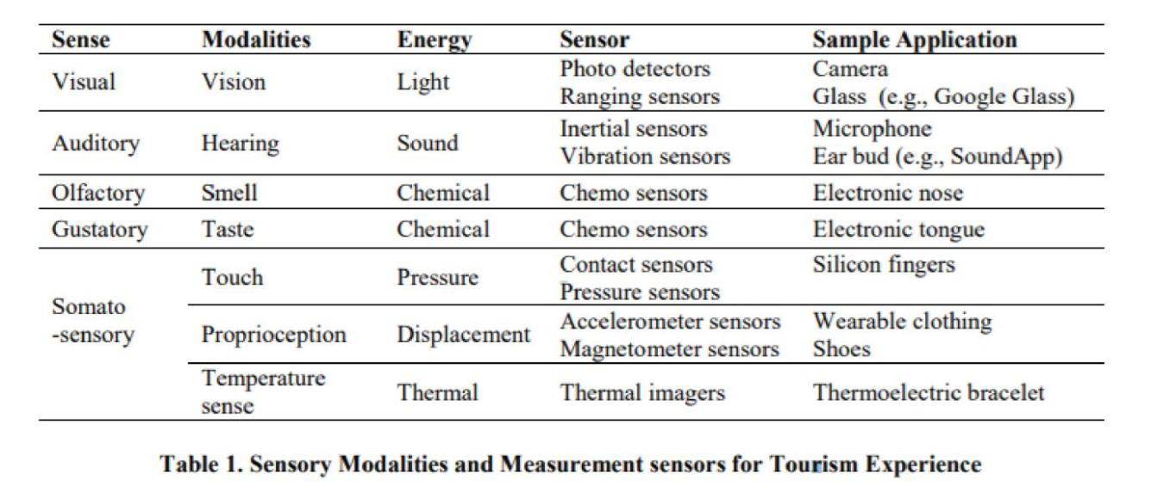

# **CHAPTER 4: THE RISE OF NATIONAL CULTURAL IDENTITY IN MODERN DESIGN**

For a long time, the traditional cultural identities of each region, the customs and habits have gradually become the material for the fine arts, but today it has changed, it seems to be wearing a new face in the design. In the last 5-10 years, the design trend has been growing, there have been strong and clear changes in creativity, the designs are easily accessible to the audience and especially Young people, combined with today's technology, has created an inspiration to spread widely on social networks

Talking about national identity, it is actually still a vague concept for many people, especially young people, because of its generalization and "book" nature. Just like talking about the symbols of lotus flower, Ao Dai, red flag with yellow star, Dong Ho painting, Buffalo, S-shaped strip of land, people immediately think of Vietnam's cultural identity.

Cultural identity is a complex structure that reflects the concept of a nation, a thought pattern, but can be expressed through such specific and specific symbols and images.

Interestingly, the creative design trend in arousing the culture is getting more and more developed and better, the contemporary design is even more deeply exploiting the national cultural identity, as a way to find the characteristics and national character in an increasingly flat world.

**5.1 The way to bring national culture into modern design**

In today's developed world of technology, something that cannot be taken away from people's hands, especially for young people, is smartphones, laptops, tablets... they help us access and learn everything through the internet. Taking advantage of that, design creators have combined with technology to turn real museums and exhibitions into online museums, online exhibitions, online libraries... easily reach anywhere with just 1 touch and click, no need to waste time traveling, especially during today's covid epidemic. The importance of the designer becomes more meaningful, creative in design also becomes stronger and more breakthrough than ever when they have awakened the hidden beauties that seemed to have been forgotten, brought to life. inspire and spread to everyone typical cultural values in general instead of following the commercial path in "exogenous" designs

In the world, there have been many people who have succeeded in incorporating elements of national culture into their designs and conquered friends from all over the world. Among them can be mentioned Yayoi Kusama, a female artist famous for her works using large and small polka dots. The round polka dot symbol with the meaning of the sun (the symbol of Japan), is energy, soft, round, lively, infinitely connected. Yayoi's polka dots attract audiences all over the world.

When the designs follow the trends and they gradually become saturated, the national cultural identity seems to be reawakened, blowing a new wind for the creative designers mainly by its simplicity, closeness, familiarity and national pride and culture of each region that are hidden deep in each person's subconscious, making it easy for designers to receive strong support from everyone through their designs.

The project "HOA VAN DAI VIET" was exhibited in 2015 and initiated by the Dai Viet Co Phong group, which has received a lot of support from the community, with the main expression being using vectors to redraw the flowers. folklore, using the rich materials available of Vietnamese culture, applied to many daily products: clothes, shoes, fashion scarves, etc. Next is the project "Vietnamese Paintings and Colors". ” - the first project on the road to digitizing Hang Trong paintings - a line of paintings with hundreds of years old in danger of disappearing, continues to receive attention.

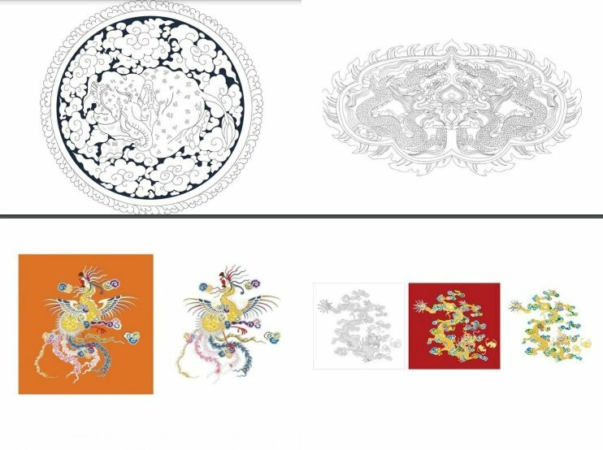

*Figure 3: Dai Viet Patterns are transformed into vectors*

It is also impossible not to mention the costume designs of the Vietnamese representative on the recent Miss Universe stage. The successive designs create a good effect, contributing to bringing the image of Vietnamese culture to international friends: Nang May (2016), Soul of Vietnam (2017), Banh Mi (2018), Café with iced milk (2019) ). Following the success, the national costume design contest representing Vietnam to participate in Miss University 2020 was kicked off with the design theme "Vietnam - Curve masterpiece".

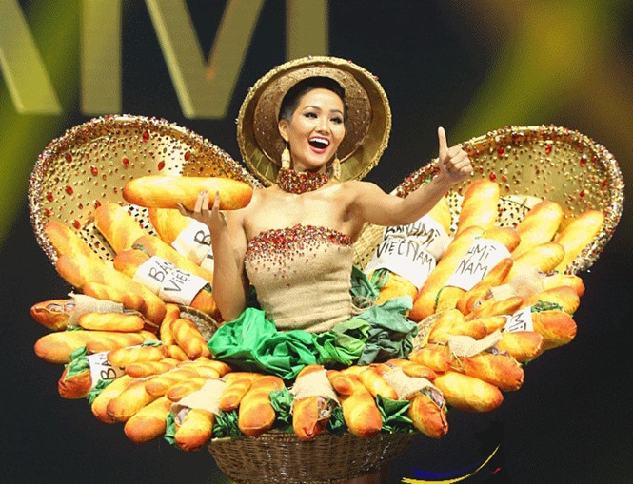

*Figure 3: Henie's bread outfit*

**5.2 National cultural identity: endless inspiration but also a challenge**

National cultural features are a strong source of inspiration for designers, but for that work to be really successful, receive sympathy and inspire people, it is extremely difficult, not everyone can do it. The designer must be a very knowledgeable person and learn to absorb the values left by our forefathers thousands of years ago, fall in love with it, love the roots from their own understanding, imbued with each breath, seep into the blood, new designers get a breakthrough in design products. It's not as simple as being mechanically stereotyped like in school, boring and monotonous

Designers must find the unique features that are decisive to impress and highlight the uniqueness of each regional culture. The more unique the feature is associated with the national identity, the greater the design value it will bring. It is also a challenge for designers, how to create their own personality, to integrate without dissolving.

1. **METHODOLOGY**

**6.1 Data collection methods**

Secondary data is compiled from statistical reports of tourism organizations experiencing tea culture in Thai Nguyen city for the period 2018 - 2021. In addition, the study also collects data from the above surveys. Internet, scientific research articles published in magazines, etc. related to the field of tourism. experience schedule and travel needs. The study uses the method of comparing absolute and relative numbers to analyze the tourism situation, the structure of travel activities, and compare the speed of tourism development over the years.

Primary data was collected through a survey of 100 tourists to Thai Nguyen city using a pre-prepared questionnaire through two forms: face-to-face interview and online interview on the Internet to analyze needs. experiential tourism demand based on the criteria of time, form and means of travel; trip purpose; attract tourists; reasons for choosing the destination; length of stay; desired activities and the cost of the trip.

**6.2 Data Analysis Methods**

The study mainly uses descriptive statistics and cross-tabulation analysis to examine the relationship of experiential tourism demand with demographic variables (gender, age, place of residence, occupation, income and status, marital status). From the results of that research combined with the actual situation of the locality, the author conducts analysis, evaluation and inference to come up with design solutions in accordance with the wishes of visitors, and at the same time create Unique beauty of Thai Nguyen Tea culture, creating attractiveness and attraction for tourists, meeting the tourism needs of tourists when coming to Thai Nguyen city.

**6.3 RESULTS AND DISCUSSION**

**6.3.1 Actual situation of tourists participating in tourism when coming to Thai Nguyen city**

There are 73 tourists (accounting for 73%) who have experienced tea culture in some districts and towns in Thai Nguyen city, in which the age group accounted for the most middle-aged people from 34 to 50, accounting for 66.4% and the lowest age group is young people aged 25 and under, accounting for only 2%). Of the 73 tourists who have experienced the culture in Thai Nguyen, up to 50 tourists were asked to follow a tour of a travel company, the rest were self-organized. This is a new type of tourism, most of them are middle-aged and older because they want to learn more about how to make tea as well as about the people here, while young people are less likely to want to go to tourist attractions. leisure schedule rather than with tourism this cultural experience

**Table 2: Types of experiential tourism that respondents have participated in**

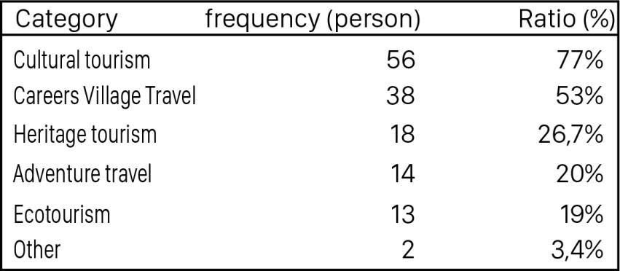

*Source: Survey results of 100 tourists in Thai Nguyen city 2021*

Experiential tourism is a very broad concept, it includes many fields of culture, ecology, education, discovery, heritage, nature... Statistics show that most tourists experience When coming to Thai Nguyen with the desire to experience the tea culture here, accounting for 77% of the respondents. Other types of tourism such as adventure tourism, heritage experience tourism, discovery experience tourism... are not chosen by many tourists when coming to Thai Nguyen. The reason is that Thai Nguyen does not have many favorable natural conditions for these activities.

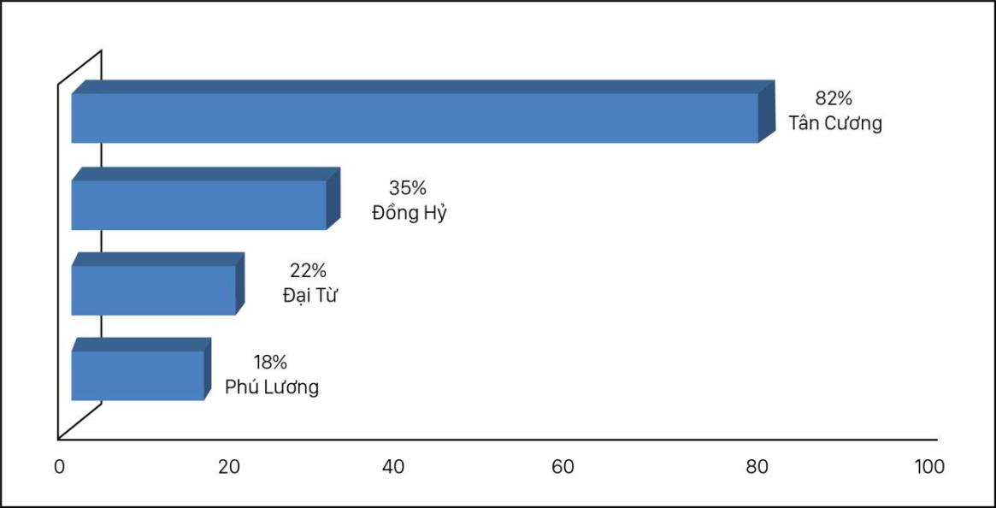

**Table 3: Tourist destination to experience Thai Nguyen culture**

The place where tourists mainly participate in experience tourism is Tan Cuong Thai Nguyen with a very high rate (82%). Because Xinjiang has a favorable geographical position for experience activities, Tan Cuong is blessed by nature with the Cong River to provide water for irrigation, and Nui Coc to shelter the fierce western sun, and also a The place has the best tea area and the oldest tea culture, so Thai Nguyen province has chosen as a key area to hold a tea culture festival here.As for districts such as Dong Hy, Dai Tu and Phu Luong, few tourists choose as tourist destinations for cultural experiences because of their geographical location far from the city center, and people have not really developed the tourism industry. experience schedule, there are not many activities for tourists to experience

Each tourist place will have its own experiences and culture of the region, especially cultural experience tourism. According to the survey results of tourists, most tourists participate in cultural experience tourism. Thai Nguyen tea wishes to have activities such as: Together with people, picking tea, making fresh tea, flavoring tea, packing handmade products. Tea, making tea and enjoying tea, enjoying dishes made from tea buds, bathing in tea leaves, cycling around the tea hill, visiting tea museum, enjoying folk songs, reciting poetry.

**Table 4: Activities in the experiential trip**

|  |  |  |
| --- | --- | --- |
| **Experiential activities** | **Frequency (Person)** | **Ratio (%)** |
| -Participate in daily activities of tea-making people (collecting tea, making tea, making fresh tea, flavoring tea, packaging tea, making tea and enjoying it). | 65 | 89 |
| -Learn about local cuisine, cook your own special dishes combined with fresh tea buds | 50 | 68,4 |
| - Walking and cycling to visit tea gardens, Cong river, Nui Coc lake | 43 | 58,9 |
| - Bath with fresh tea leaves | 24 | 32,8 |
| -Enjoy folk tunes, reciting poems, lyric songs... | 15 | 20,5 |
| -Other | 5 | 6,8 |

**6.3.2 Experiential tourism needs of tourists when coming to Thai Nguyen**

***6.3.2.1 Desired time to participate in experiential tourism***

The majority of tourists want to participate in experiential tourism during summer vacation (36%) and anytime they want to go (34%). Tet and public holidays account for a relative proportion of 21%. Weekends are not chosen by many people to experience travel (8%) and a small number of respondents answered that they only travel when they are economically eligible (1%).

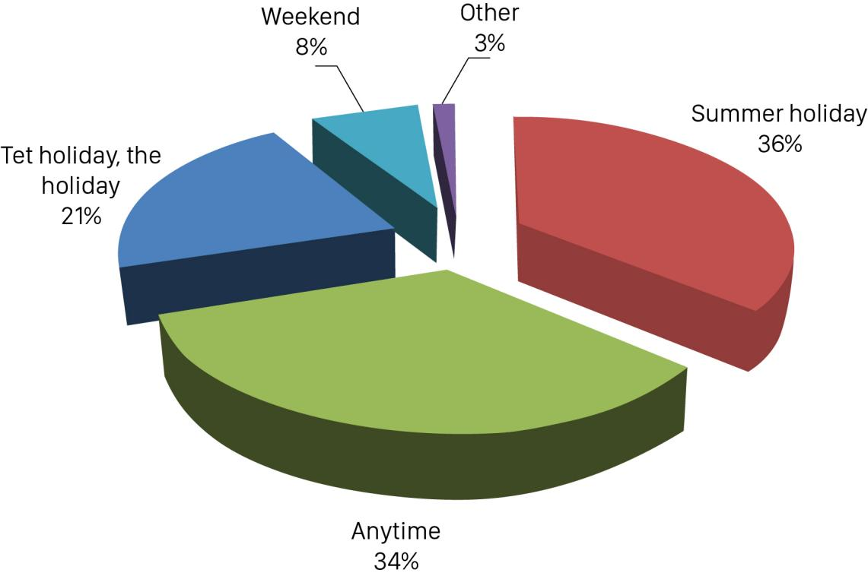

**Table 5: Desired time to participate in experiential tourism**

*Source: Survey results of 100 visitors to experience in Thai Nguyen*

However, each different target group will have different leisure time to travel. Therefore, in order to help tour operators have more specific information about the desired time to travel to experience each age group so that they can build appropriate travel programs, the study analyzes the table below. and the results are presented in Table 6.

The age group under 20 is mostly students, so the idle time is in the summer months. The majority of people aged 35 and above are married and have children, so their leisure time is quite limited, so they only prioritize traveling during long breaks such as Tet, major holidays of the year or other holidays to bring the kids along. The age group from 20 to 34 has the most leisure time, is flexible, and actively arranges time to have trips to experience for themselves. In addition, this is also the age when they love to travel at any time they want. The youth, dynamism, love of challenges, freedom, fickleness, and unwillingness to be constrained to certain frameworks have had a significant impact on the tourism behavior of this target group. This is also one of the challenges for travel companies when it is difficult to grasp their psychology and real needs.

|  |  |  |  |  |  |  |  |  |  |  |
| --- | --- | --- | --- | --- | --- | --- | --- | --- | --- | --- |
| Time | under 20 years old | | 20-34 years old | | 35-49 years old | | From 50 years old | | Total | |
| People | Ratio  (%) | People | Ratio  (%) | People | Ratio  (%) | People | Ratio  (%) | People | Ratio  (%) |
| Weekends | 0 | 0 | 3 | 12,5 | 1 | 7,1 | 1 | 6,25 | 5 | 6,8% |
| Tet holidays and holidays | 2 | 12,5 | 3 | 12,5 | 6 | 42,8 | 4 | 25 | 15 | 20,5% |
| Summer holiday | 12 | 75 | 8 | 33,3 | 3 | 21,4 | 3 | 18,75 | 26 | 35,6% |
| Anytime | 2 | 12,5 | 10 | 41,6 | 4 | 28,5 | 8 | 50 | 24 | 32,8% |
| Other | 0 | 0,0 | 1 | 4,1 | 1 | 7,1 | 1 |  | 3 | 4,1% |
| Total | 16 | 100,0 | 24 | 100,0 | 14 | 100,0 | 16 | 100,0 | 73 | 100% |

**Table 6: Relationship between age and desired duration of travel experience**

*Source: Survey result of 100 tourists experience in Thai Nguyen*

***6.3.2.2 Means used when participating in experiential tourism***

Nearly half of the respondents (49%) choose motorbikes for their future trips. For them, motorbikes are both the most cost-effective and convenient, giving them real experiences on the roads, clearly feeling the change of natural scenery and people's lives in different places. Passenger cars are also the vehicle chosen by many respondents with 32%, followed by personal cars with 14.5%. Passenger cars and personal cars bring comfort and convenience, helping tourists to rest while traveling, especially those with poor physical strength, suitable for remote destinations and families There are adults and children. And the rest are other vehicles accounting for 4.5%.

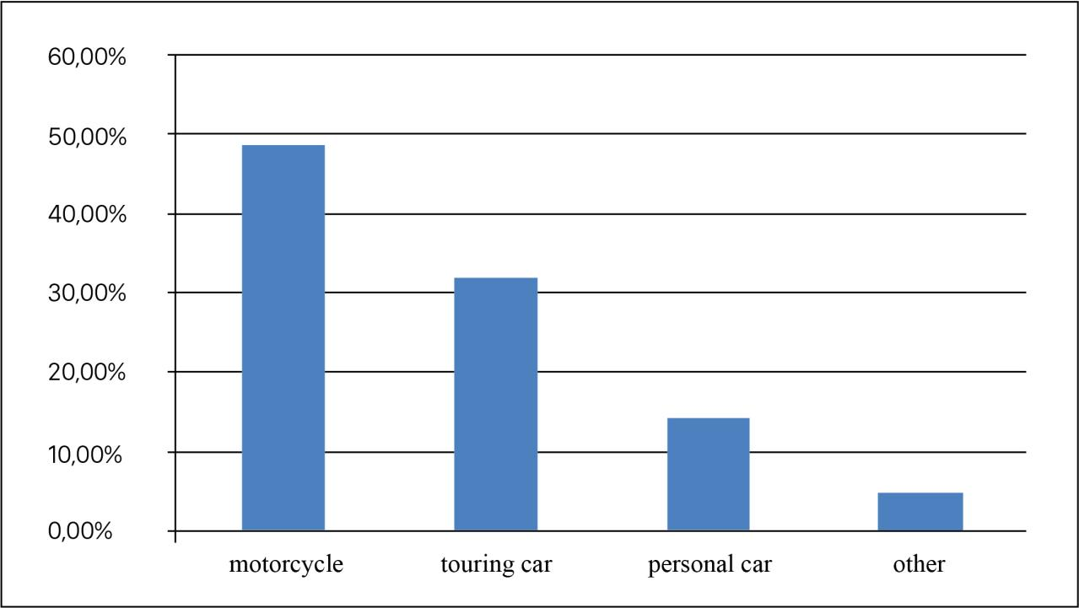

**Table 7: Means of choosing to participate in experiential tourism**

*Source: Survey result of 100 tourists experience in Thai Nguyen*

**6.3.2.3 Desired activity to experience**

By synthesizing answers from 100 tourists experiencing Thai Nguyen tea culture, the study has grouped activities that they want to experience. Visitors experience the desire to learn about culture (hand-picking tea on the garden hill, making tea and jarring tea by hand, cooking and enjoying local specialties combined with fresh tea leaves; activities with local people; hand-pack tea as handmade gifts in traditional craft villages; cultural exchanges, participate in folk games and festivals; learn about and listen to stories about relics , heritage). Learning about the culture in different places has never ceased to attract visitors, especially the tea culture here. Not only stopping to enjoy, visitors also want to learn more about processing, historical origin, as well as want to learn more about tea varieties under the direct guidance of local people. Even at the end of the journey, returning to their daily living place every time they enjoy tea, they have a clear understanding of tea culture.

1. **CONCLUSION**

The survey results have shown the current situation of the tourism industry to experience the tea culture of Thai Nguyen, and at the same time show the needs and desires that tourists come to experience. In recent years, Thai Nguyen and especially the indigenous people have gradually promoted strongly the distinct cultural features of the tea area to tourists, the people's life has also improved markedly compared to other countries years ago when only knew how to grow tea and sell tea. But to attract tourists from the young generation to the elderly, it is not just an experience but also arousing tea culture through contemporary design elements, and it becomes more and more necessary. More than when the covid epidemic is still happening very complicatedly, good design elements will inspire and touch the hearts of viewers, making tourists really want to come to Thai Nguyen once to experience the culture

Travel businesses in Thai Nguyen city need to survey and exploit tourism products to experience in Thai Nguyen, closely linked with the characteristics of each region to help visitors feel the difference. unique, new compared to the traditional tours before. Travel companies should design tours with a travel time (holidays, Tet, summer vacations) suitable for the length of stay (from 3 to 7 days) so that visitors do not feel bored or tired. The unique and separate tour program with new and novel experiences really attracts the group of people who organize themselves to go and go alone. The company needs to have a tour designed specifically for each different target group, especially female customers and households participating in traveling experiences together. Women are traveling more and more and they are also willing to spend more than men.

Therefore, if travel agencies design tours specifically for them, they will surely attract and be interested in this group of potential customers. In addition, for households, the tour should have activities for members to experience together, a comfortable and cozy space combined with more collective activities, outdoor activities to bond group members together and develop social relationships.

https://mythuat.vanlanguni.edu.vn/vi/tin-tuc-hoat-dong-khoa/119-su-troi-day-cua-ban-sac-van-hoa-dan-toc-trong-thiet-ke-hien-dai?fbclid=IwAR1aMj3aPQEXg1VbwjGKYSTm_z67Wv7dDwlck6iUI1U2bVLVxScafh5R-OE

# REFERENCES

Apostolakis, A., 2015. *researchgate.net.* [Online]   
Available at: https://www.researchgate.net/publication/319351326_The_Emergence_of_Experiential_Tourism_Activity_Reasons_and_Rationale

elsevier, 2020. *sciencedirect.com.* [Online]   
Available at: https://www.sciencedirect.com/science/article/pii/S0160738320300669?fbclid=IwAR18Oogt809wig7JZ96seRR9kTyGDcpoSVkL3Dq2Fq1PDj8IJva4JltiNn0

Norah, J., 2018. *independenttravelcats.com.* [Online]   
Available at: https://independenttravelcats.com/thai-nguyen-visit-vietnams-tea-region-footprint-travel/?fbclid=IwAR2d71PGObgZwdW92ZR6S9-7nPN01TqfZSk_SRwzRHQ8GJcd8_X-3f2Edyc

Smith, W. L., n.d. *yumpu.com.* [Online]   
Available at: https://www.yumpu.com/en/document/read/7282827/1-experiential-tourism-around-the-world-and-at-home-definitions-

tien, T., 2020. *khoaluantotnghiep.com.* [Online]   
Available at: https://khoaluantotnghiep.com/du-lich-cong-dong-la-gi/?fbclid=IwAR2osfCjBEO4RHG0sn5BGXYivpV_rwEoQp8CxEH107YPle2VOEFGjEJqbJ0

Tussyadiah, I., 2014. *researchgate.net.* [Online]   
Available at: https://www.researchgate.net/figure/The-Fundamentals-for-Tourism-Experience-Design_fig1_266732531?fbclid=IwAR2fMa_KYJC8PmnnBzYgATE00J9QPI_wLiL5n7H-pt_Oy4P69GzU2lDMH50

Tussyadiah, I., 2014. *researchgate.net.* [Online]   
Available at: https://www.researchgate.net/figure/The-Fundamentals-for-Tourism-Experience-Design_fig1_266732531?fbclid=IwAR2fMa_KYJC8PmnnBzYgATE00J9QPI_wLiL5n7H-pt_Oy4P69GzU2lDMH50

Tussyadiah, I., 2014. *researchgate.net.* [Online]   
Available at: https://www.researchgate.net/publication/266732531_Toward_a_Theoretical_Foundation_for_Experience_Design_in_Tourism

Ảnh

<http://thainguyencity.gov.vn/home/news/?10704/Nhung-diem-den-dep-o-vung-%E2%80%9Cde-nhat-danh-tra%E2%80%9D-Thai-Nguyen.htm>

http://www.vtr.org.vn/thai-nguyen-phat-trien-du-lich-cong-dong-theo-huong-ben-vung.html

<https://inkythuatso.com/mau-thiet-ke-vector/hoa-van-dai-viet-vector-2562.html>

https://ngoisao.vnexpress.net/h-hen-nie-gap-su-co-sat-gio-dien-trang-phuc-banh-mi-3852280.html